**Industrial Internship Report on**

**”Music Player Application”**

**Prepared by**

**[Md Intakhab]**

|  |
| --- |
| *Executive Summary* |
| This report provides details of the Industrial Internship provided by upskill Campus and The IoT Academy in collaboration with Industrial Partner UniConverge Technologies Pvt Ltd (UCT).  This internship was focused on a project/problem statement provided by UCT. We had to finish the project including the report in 6 weeks’ time.  My project was the music player application built with JavaFX is a versatile media player that supports both audio and video playback. It offers seamless access to local files on the user's system and provides a user-friendly interface for easy navigation and control. With its robust features and intuitive design, it promises an enjoyable media experience for users seeking a flexible and efficient media player solution.  This internship gave me a very good opportunity to get exposure to Industrial problems and design/implement solution for that. It was an overall great experience to have this internship. |

**TABLE OF CONTENTS**

1 Preface 3

2 Introduction 4

2.1 About UniConverge Technologies Pvt Ltd 4

2.2 About upskill Campus 8

2.3 Objective 9

2.4 Reference 9

2.5 Glossary 10

3 Problem Statement 11

4 Existing and Proposed solution 12

5 Proposed Design/ Model 13

5.1 High Level Diagram (if applicable) 13

5.2 Low Level Diagram (if applicable) 13

5.3 Interfaces (if applicable) 13

6 Performance Test 14

6.1 Test Plan/ Test Cases 14

6.2 Test Procedure 14

6.3 Performance Outcome 14

7 My learnings 15

8 Future work scope 16

# Preface

Summary of the whole 6 weeks’ work.

About need of relevant Internship in career development.

Brief about Your project/problem statement.

Opportunity given by USC/UCT.

How Program was planned

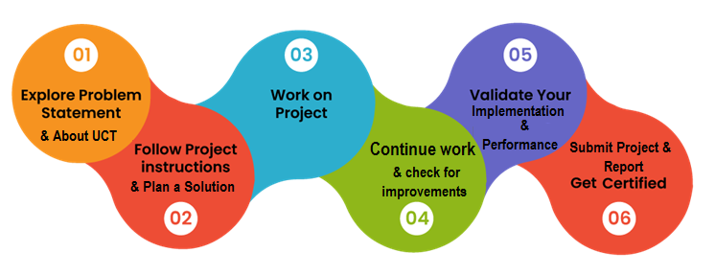

Your Learnings and overall experience.

Thank to all (with names), who have helped you directly or indirectly.

Your message to your juniors and peers.

# Introduction

## About UniConverge Technologies Pvt Ltd

A company established in 2013 and working in Digital Transformation domain and providing Industrial solutions with prime focus on sustainability and RoI.

For developing its products and solutions it is leveraging various**Cutting Edge Technologies e.g. Internet of Things (IoT), Cyber Security, Cloud computing (AWS, Azure), Machine Learning, Communication Technologies (4G/5G/LoRaWAN), Java Full Stack, Python, Front end**etc.

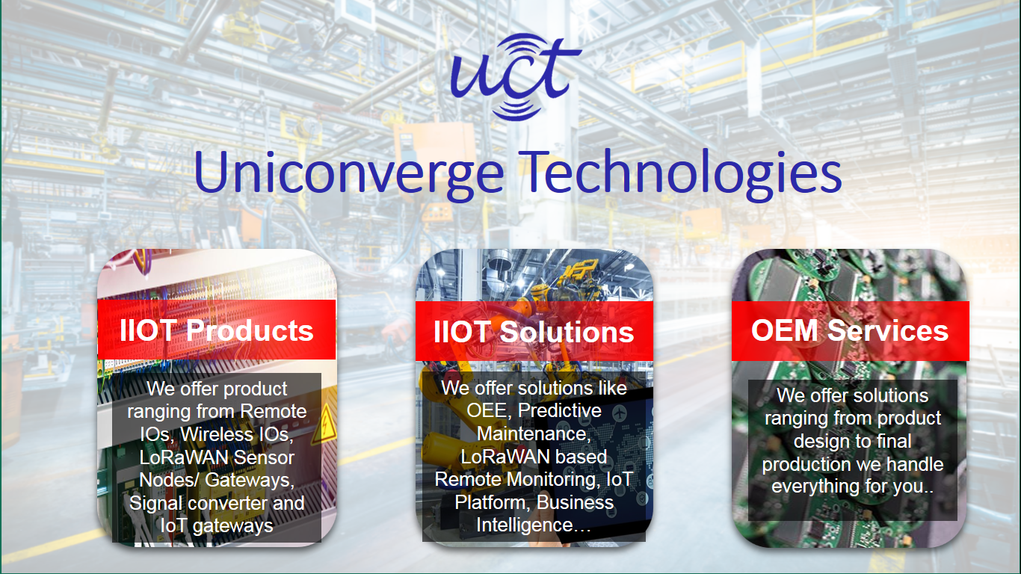

1. UCT IoT Platform **(****)**

**UCT Insight** is an IOT platform designed for quick deployment of IOT applications on the same time providing valuable “insight” for your process/business. It has been built in Java for backend and ReactJS for Front end. It has support for MySQL and various NoSql Databases.

* It enables device connectivity via industry standard IoT protocols - MQTT, CoAP, HTTP, Modbus TCP, OPC UA
* It supports both cloud and on-premises deployments.

It has features to  
• Build Your own dashboard  
• Analytics and Reporting  
• Alert and Notification  
• Integration with third party application(Power BI, SAP, ERP)  
• Rule Engine

 

1. **Smart Factory Platform (****)**

Factory watch is a platform for smart factory needs.

It provides Users/ Factory

* with a scalable solution for their Production and asset monitoring
* OEE and predictive maintenance solution scaling up to digital twin for your assets.
* to unleased the true potential of the data that their machines are generating and helps to identify the KPIs and also improve them.
* A modular architecture that allows users to choose the service that they what to start and then can scale to more complex solutions as per their demands.

Its unique SaaS model helps users to save time, cost and money.

 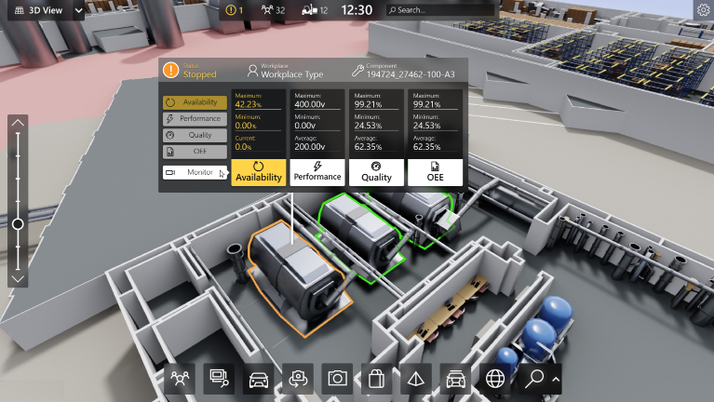

1. 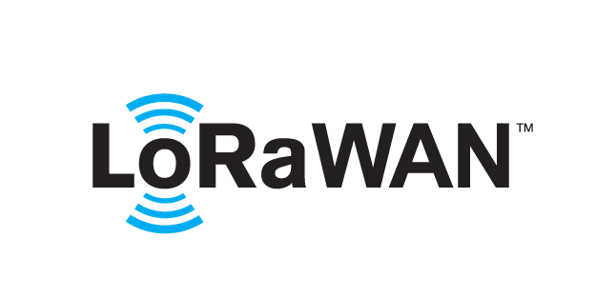 based Solution

UCT is one of the early adopters of LoRAWAN teschnology and providing solution in Agritech, Smart cities, Industrial Monitoring, Smart Street Light, Smart Water/ Gas/ Electricity metering solutions etc.

1. Predictive Maintenance

UCT is providing Industrial Machine health monitoring and Predictive maintenance solution leveraging Embedded system, Industrial IoT and Machine Learning Technologies by finding Remaining useful life time of various Machines used in production process.



## About upskill Campus (USC)

upskill Campus along with The IoT Academy and in association with Uniconverge technologies has facilitated the smooth execution of the complete internship process.

USC is a career development platform that delivers **personalized executive coaching** in a more affordable, scalable and measurable way



Seeing need of upskilling in self paced manner along-with additional support services e.g. Internship, projects, interaction with Industry experts, Career growth Services

<https://www.upskillcampus.com/>

upSkill Campus aiming to upskill 1 million learners in next 5 year

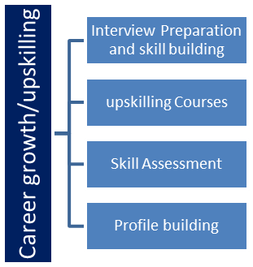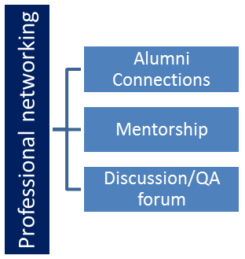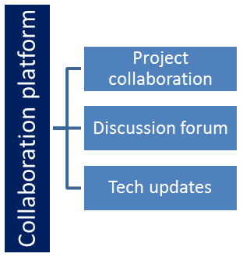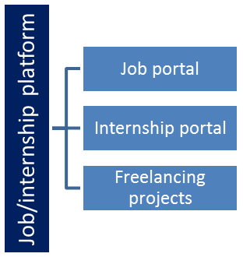

## The IoT Academy

The IoT academy is EdTech Division of UCT that is running long executive certification programs in collaboration with EICT Academy, IITK, IITR and IITG in multiple domains.

## Objectives of this Internship program

The objective for this internship program was to

 ☛ get practical experience of working in the industry.

 ☛ to solve real world problems.

 ☛ to have improved job prospects.

 ☛ to have Improved understanding of our field and its applications.

 ☛ to have Personal growth like better communication and problem solving.

## Reference

[1] Youtube

[2] ChatGpt

[3] Geeksforgeeks

## Glossary

|  |  |
| --- | --- |
| Terms | Acronym |
|  |  |
|  |  |
|  |  |
|  |  |
|  |  |

# Problem Statement

The challenge is to create a feature-rich music player application using JavaFX that can effectively handle both audio and video files. The application must seamlessly access media from the user's system, offering smooth playback, pause, stop, volume control, and seeking functionalities. Supporting various file formats and codecs will be critical to ensure compatibility with a wide range of media types. The player should also provide a visually appealing and intuitive user interface, allowing users to easily browse and manage their media library.

Ensuring optimal performance and responsiveness, even with large media files, will be a key consideration. The application must handle potential issues such as buffering delays, synchronization problems, and memory management efficiently. Additionally, providing smooth transitions between different media files and the ability to create playlists are essential features to enhance the user experience.

Moreover, it's vital to address potential security concerns and prevent unauthorized access to sensitive files on the user's system. Ensuring the application is robust, stable, and able to recover gracefully from unexpected errors will be crucial for maintaining user satisfaction.

In conclusion, the challenge lies in creating a comprehensive music player that excels in functionality, performance, and user-friendliness while addressing potential security and stability concerns, to provide an immersive multimedia experience for users.

# Existing and Proposed solution

Summary of Existing Solutions and Limitations:

Existing music player applications offer various functionalities for audio and video playback. Many are capable of handling different file formats and provide a user-friendly interface for easy navigation and control. Some solutions also offer playlist management, equalizer settings, and online streaming integration.

However, these existing solutions often have limitations. Some might lack cross-platform support, restricting usage to specific operating systems. Others might suffer from performance issues when handling large media files or lack responsiveness in complex user interactions. Additionally, certain players may lack the flexibility to customize the user interface to suit individual preferences fully. Security concerns might arise when accessing files from the user's system, potentially exposing sensitive data to vulnerabilities.

Proposed Solution:

Our proposed solution is a JavaFX-based music player application that overcomes the limitations of existing solutions. It will be designed with cross-platform compatibility in mind, allowing users to access the application from various operating systems seamlessly. To ensure smooth performance, we will implement efficient media handling techniques, including buffering and resource management, even for large media files.

Value Addition:

Our music player will provide an intuitive user interface, allowing users to customize the layout and appearance according to their preferences. We will prioritize security and implement robust access control measures to protect users' sensitive data. Additionally, the player will support a wide range of audio and video formats, ensuring maximum compatibility with different media types.

In terms of features, our music player will offer advanced playlist management, including the ability to create, edit, and save playlists. We will implement an equalizer with various presets and the option for users to customize their audio settings. Furthermore, integration with online streaming platforms will enable users to access a vast library of music and videos directly from the application.

Our goal is to deliver a comprehensive, user-friendly, and reliable music player that enhances the multimedia experience for users, setting it apart from existing solutions in terms of performance, functionality, and customization options.

## Code submission (Github link)

https://github.com/Intakhab08/upskill_campus

## Report submission (Github link) : first make placeholder, copy the link.

# Proposed Design/ Model

Given more details about design flow of your solution. This is applicable for all domains. DS/ML Students can cover it after they have their algorithm implementation. There is always a start, intermediate stages and then final outcome.

## High Level Diagram (if applicable)

Figure 1: HIGH LEVEL DIAGRAM OF THE SYSTEM

## Low Level Diagram (if applicable)

## Interfaces (if applicable)

Update with Block Diagrams, Data flow, protocols, FLOW Charts, State Machines, Memory Buffer Management.

# Performance Test

This is very important part and defines why this work is meant of Real industries, instead of being just academic project.

Here we need to first find the constraints.

How those constraints were taken care in your design?

What were test results around those constraints?

Constraints can be e.g. memory, MIPS (speed, operations per second), accuracy, durability, power consumption etc.

In case you could not test them, but still you should mention how identified constraints can impact your design, and what are recommendations to handle them.

## Test Plan/ Test Cases

1.Functional Testing:

a. Playback Functionality:

Test audio file playback.

Test video file playback.

Test playback controls (play, pause, stop, seek).

Verify playback smoothness and synchronization.

b. Media File Handling:

Test with various audio and video formats to ensure compatibility.

Test with large media files to assess performance and resource handling.

Verify the application's response to corrupted or unsupported files.

c. User Interface:

Test all user interface elements for responsiveness and correct behavior.

Verify the appearance and functionality of customizable themes/skins.

Test Case: Audio Playback

Description: Verify that the music player can play audio files correctly.

Steps:

Open the music player application.

Add an audio file to the playlist.

Click the "Play" button.

Expected Result: The audio file should start playing, and the progress bar should move accordingly.

Test Case: Video Playback

Description: Verify that the music player can play video files with both audio and video tracks.

Steps:

Open the music player application.

Add a video file to the playlist.

Click the "Play" button.

Expected Result: The video file should start playing, and both audio and video tracks should be synchronized.

## Test Procedure

1: Functional Testing:

a. Playback Functionality:

Start the music player application.

Add audio and video files of various formats to the playlist.

Click the "Play" button for each file and observe the playback.

Test the pause, stop, and seek functionalities during playback.

Verify that audio and video tracks are synchronized correctly.

b. Media File Handling:

Test the application with different audio and video file formats (e.g., MP3, WAV, MP4, MKV).

Add large audio and video files to the playlist and ensure smooth playback.

Attempt to play corrupted or unsupported files and verify the application's response.

## Performance Outcome

->Load the application with a large library of media files (audio and video).

->Monitor CPU and memory usage during media playback and playlist management.

->Check for any performance bottlenecks or slowdowns during these activities.

# My learnings

In the process of creating a JavaFX-based music player application, I gained valuable insights into software development and user interface design. I learned how to handle multimedia files efficiently, implement smooth playback, and manage resources effectively. Understanding cross-platform compatibility and security measures was crucial to ensure a reliable and secure application. Additionally, I enhanced my skills in creating an intuitive user interface, allowing customization and seamless navigation. Through this project, I acquired hands-on experience in addressing performance challenges, like handling large files, buffering, and optimizing responsiveness. Overall, the project taught me the significance of user-centric design and the value of continuous improvement in software development.

# Future work scope

In the future, the software industry is expected to witness significant growth in areas such as Artificial Intelligence (AI) and Machine Learning (ML), Internet of Things (IoT), Cybersecurity, Cloud Computing, and Blockchain Technology. Additionally, augmented reality (AR) and virtual reality (VR) development, data science, and big data analysis will be in high demand. DevOps practices and automation will continue to gain prominence. Mobile app development will remain relevant, emphasizing improved user experiences. Sustainable and green software solutions will gain attention as environmental concerns increase. Although still in early stages, quantum computing may present new opportunities. Overall, software professionals must keep pace with emerging technologies and acquire relevant skills to thrive in this ever-evolving industry.